**Unit 7: Hypothesis Testing Worksheet**

**Exercise 7.1 The Related Samples T Test**

*Q: Recall that in the previous unit exercises, a two-tailed test was undertaken whether the population mean impurity differed between the two filtration agents in Data Set G. Suppose instead a one-tailed test had been conducted to determine whether Filter Agent 1 was the more effective. What would your conclusions have been?*

A: The results of the Hypothesis testing are shown in the picture below , and the Formulation of the Null Hypothesis for the one-tailed test would be that Agent 1 is not more effective than Agent 2 (i.e. (H0 is μ1 >= μ2), while the Alternative Hypothesis H1 is that Agent 1 is more effective (i.e. μ1< μ2).

When comparing the test data *t Stat* and *t Critical one-tail*, we find that *t Stat* < *- t Critical one-tail,* and we also see that *P(T<=t) one-tail t* < 0.05 therefore we can reject the null hypothesis.

According to the testing, Agent 1 is significantly more effective than Filter Agent 2 at reducing impurities, and this conclusion is the same as with the one from the two-tailed test that Agent 1 is the recommended choice for the filtration process.

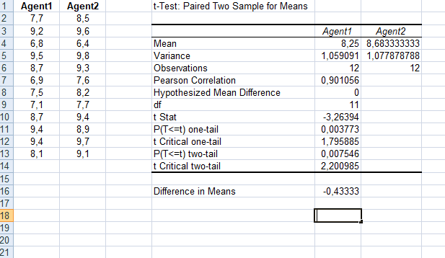

**Exercise 7.2 The Independent Samples T Test**

Q: Consider the bank cardholder data of Data Set C. Open the Excel workbook Exa8.6C.xlsx which contains this data from the Exercises folder. Assuming the data to be suitably distributed, complete an appropriate test of whether the population mean income for males exceeds that of females and interpret your findings. What assumptions underpin the validity of your analysis, and how could you validate them?

A”: We assume that the population variances underlying the incomes of men and women do not differ, and we use the F-test Two-sample for Variances with the null hypothesis being that the variances are significantly different and the alternate hypothesis is that the variances are equal. The results of the test are in the image below:

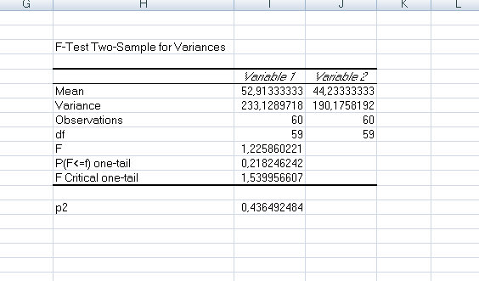

From the F-Test in Excel we find that p2 = 0, 43649 (reject the null Hypothesis) and that the observed F test statistic = 1,225860221. The observed F ratio is therefore not significant and we can use the Two-Sample t-test Assuming Equal Variances to test if the population mean income for males exceeds that of females.

From this test we find that t = 3.268 with 118 degrees of freedom. The two-tailed p-value is p = 0.00142, so the observed t is significant. The results strongly suggest that the income for men is greater than that of women, with a difference in Means of 8, 68.

